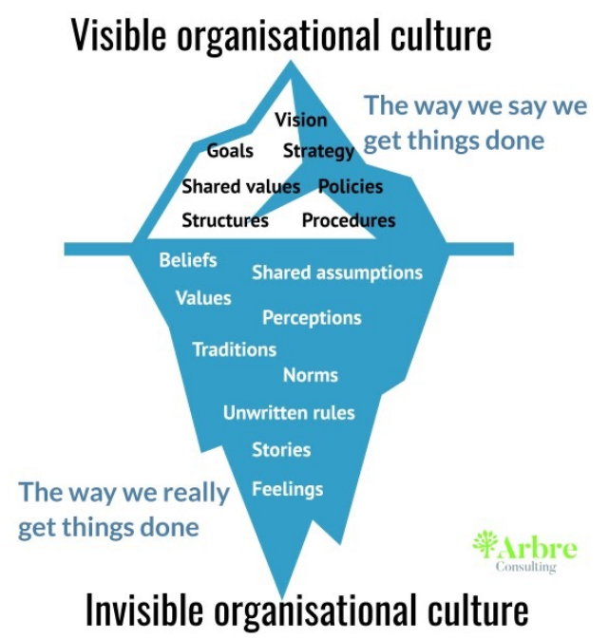
Culture and Project Management
- Definition of Organizational Culture
- Project Manager’s Checklist
- Team Challenges
- Dealing with conflict

Organizational Culture
- Shared beliefs, attitudes, values
- Behaviours that arise from the beliefs, attitudes and values
- May be obvious or subtle

Project Manager’s Checklist
- Decision-making—who makes the decision and what processes are followed
- Communication
  - Formality
  - Medium
  - Complexity
- Vocabulary and format— “Image”

Team Challenges
- Individual identity
- Verbal and emotional expressiveness
- Relationship expectations
- Style of communication
- Language
- Personal priorities, values and beliefs
- Time orientation

Dealing with Conflict
- Conflict is not a bad thing
- Problem-solving is a key activity for successful teams
- Understanding your own preferred approach and those of your team helps in productive conflict resolution

Five basic approaches to conflict resolution
- Avoidance
- Accommodation
- Competition
- Compromise
- Collaboration

Culture and Project Management
- Organizational Culture means shared beliefs, attitudes and values, along with related behaviours
- Project Managers need to be aware of cultural issues
- Team Members can also face challenges in cross-cultural relationships
- Effectively dealing with conflict is a success factor for projects—every project team must resolve differences and make decisions

